- Enable CloudTrail monitoring and store the events in S3 and CloudWatch log events.
I created one cloud trail and configured to store the logs in S3 and Cloud watch.
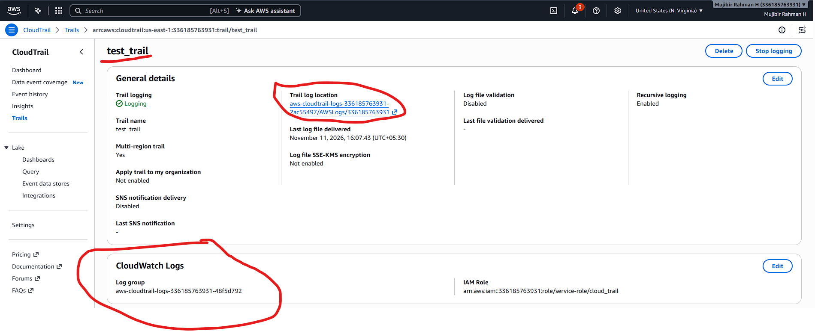
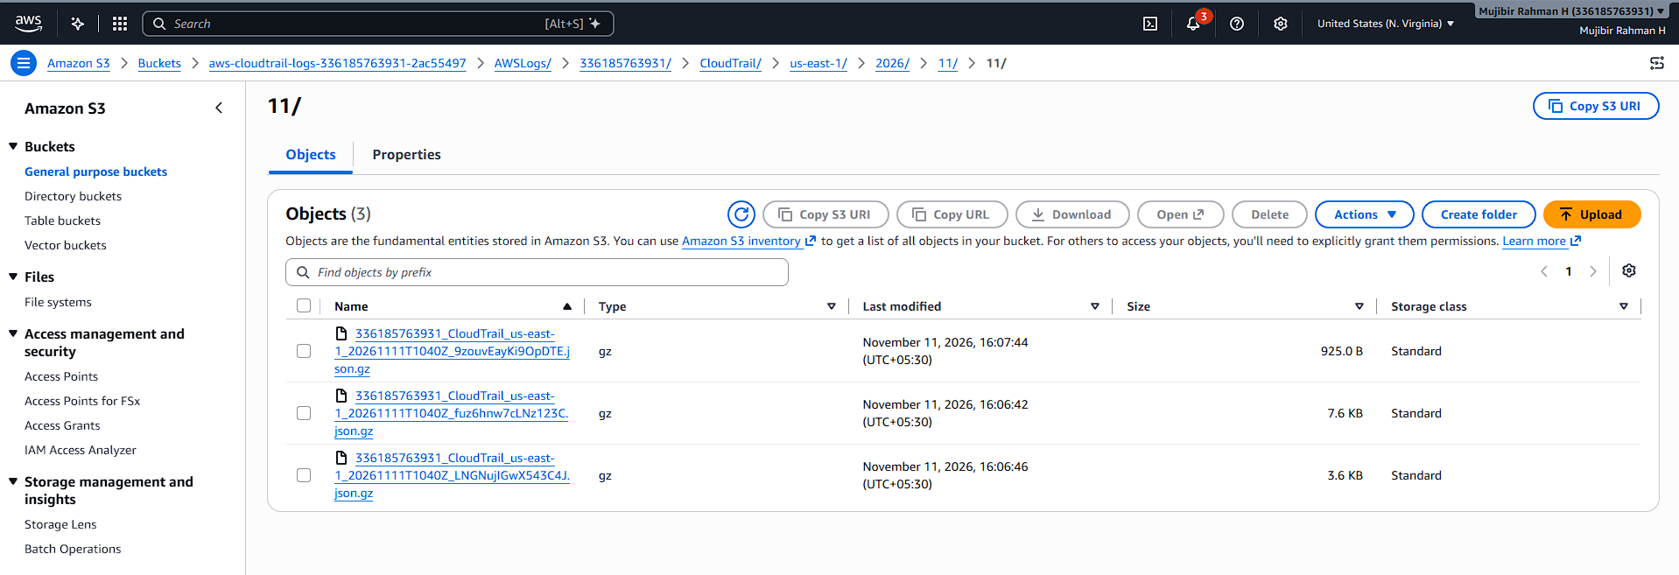
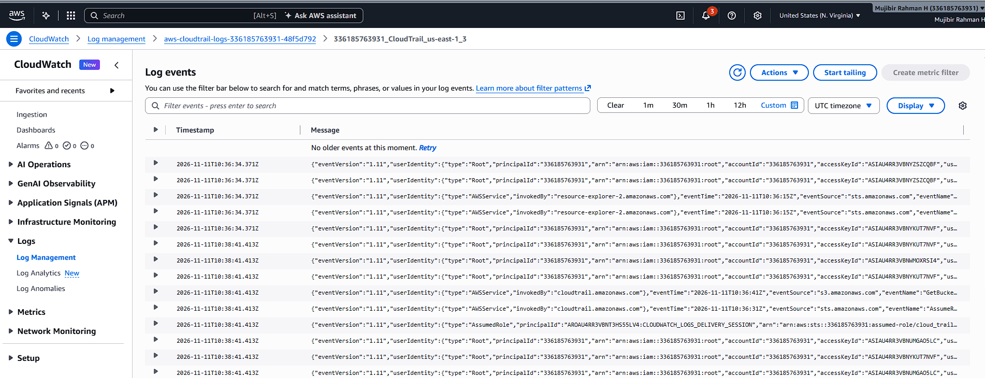
- Enable SNS for CloudTrail to send alerts via email.
I configured the SNS topic and subscription. I added my mail id for alerts. After adding the mail in Subscription, we need to confirm through mail. Then only subscription will activate.
I configured the sns in cloud trail.
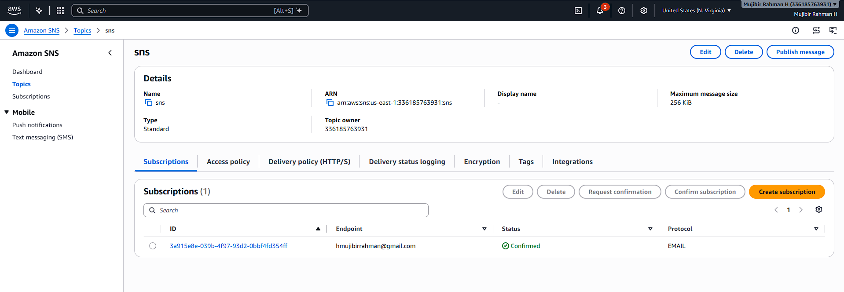
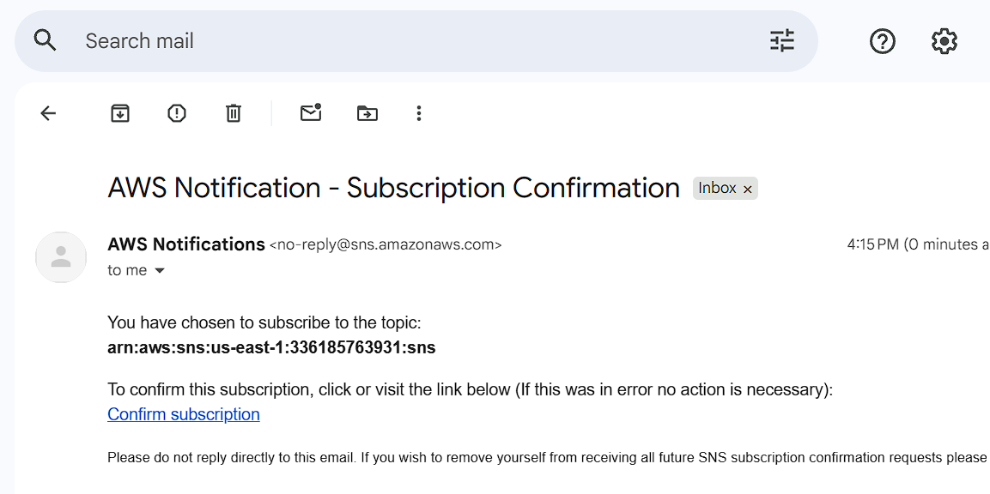
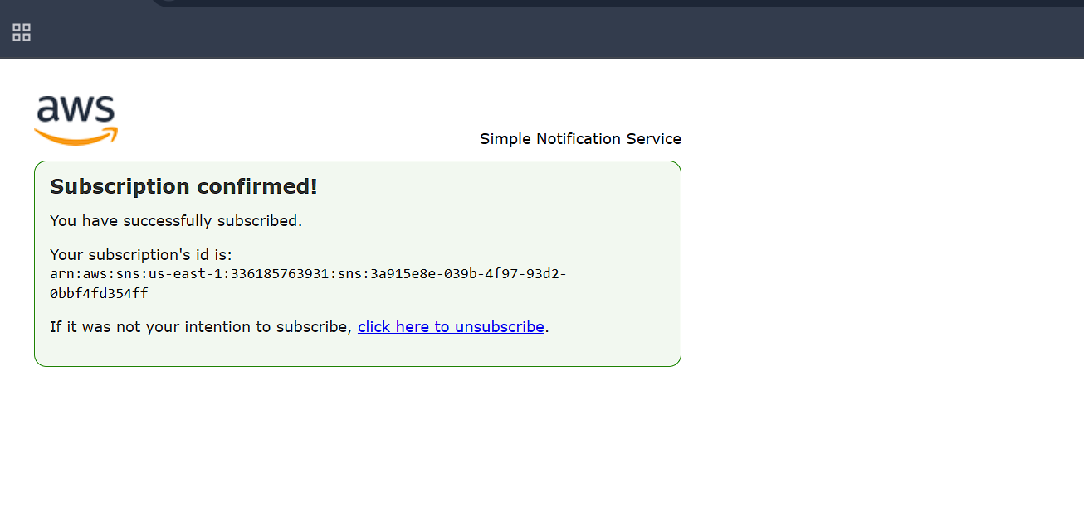
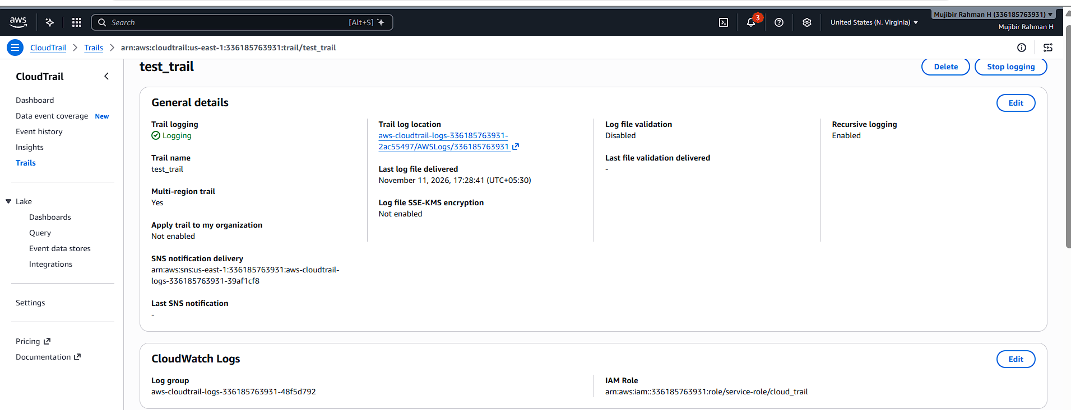
- Configure CloudWatch monitoring and record the CPU utilization and other metrics of EC2.
In AWS, we have default monitoring setting for some default metrics.
If we want to get the details for every minute instead of every 5 minutes (Default configured one) we need to enable the detailing monitoring that is optional and it’s chargeable.
In cloud Watch, I already setup the dashboards, we can monitor from there.
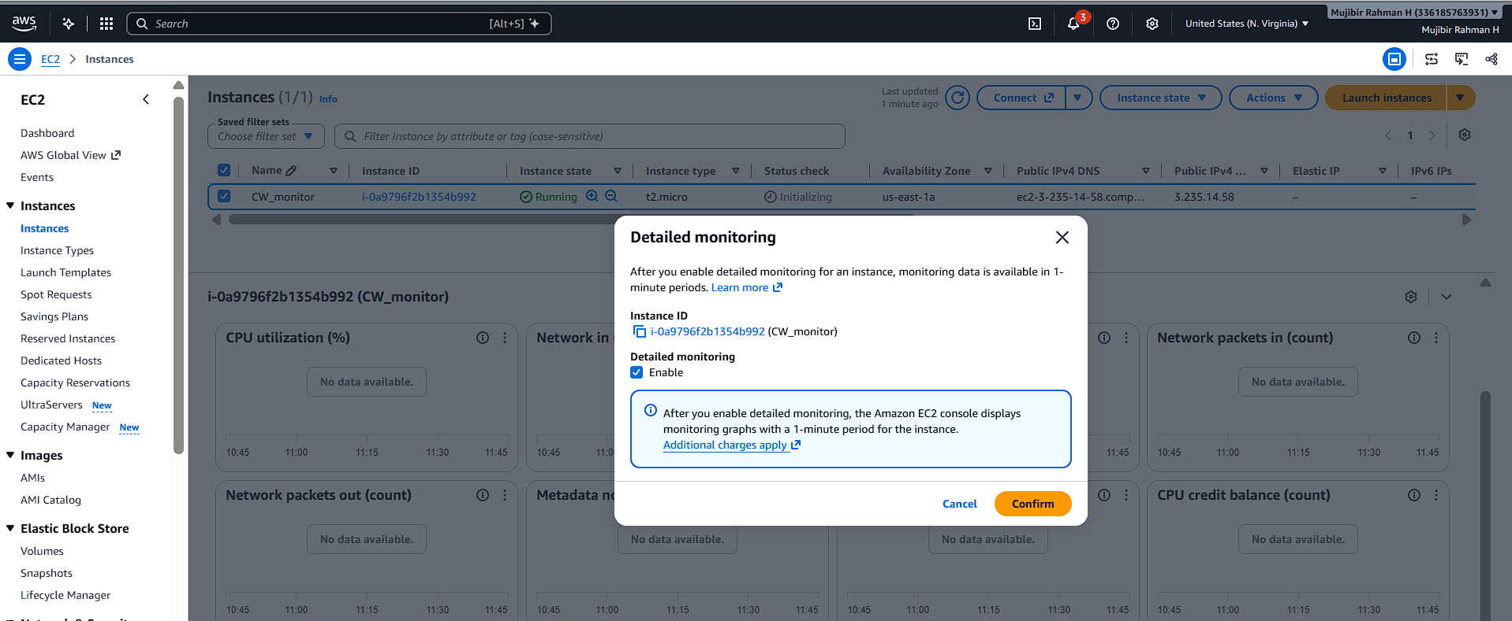
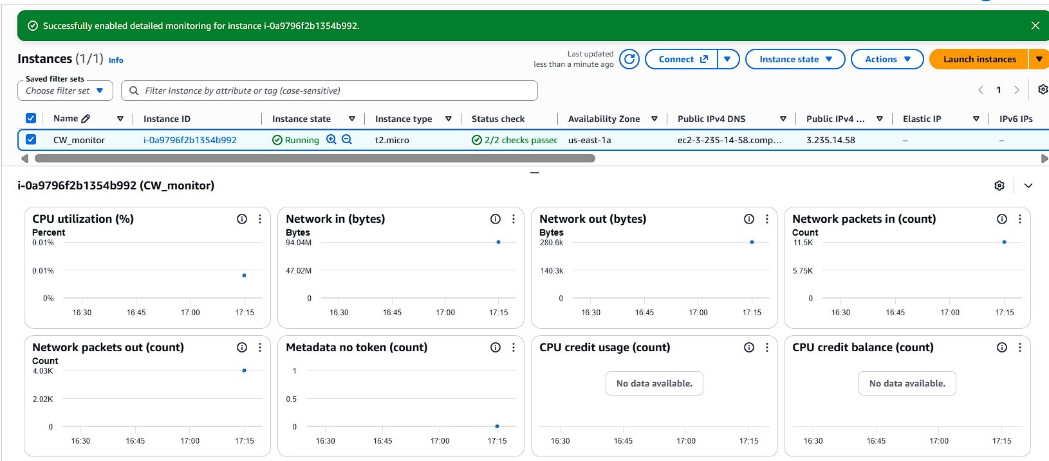
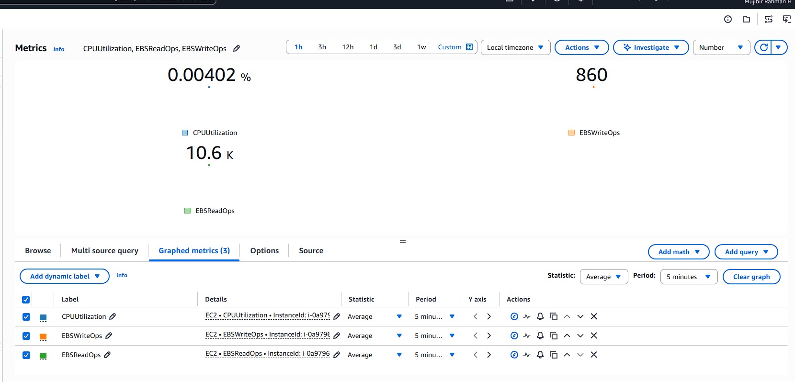
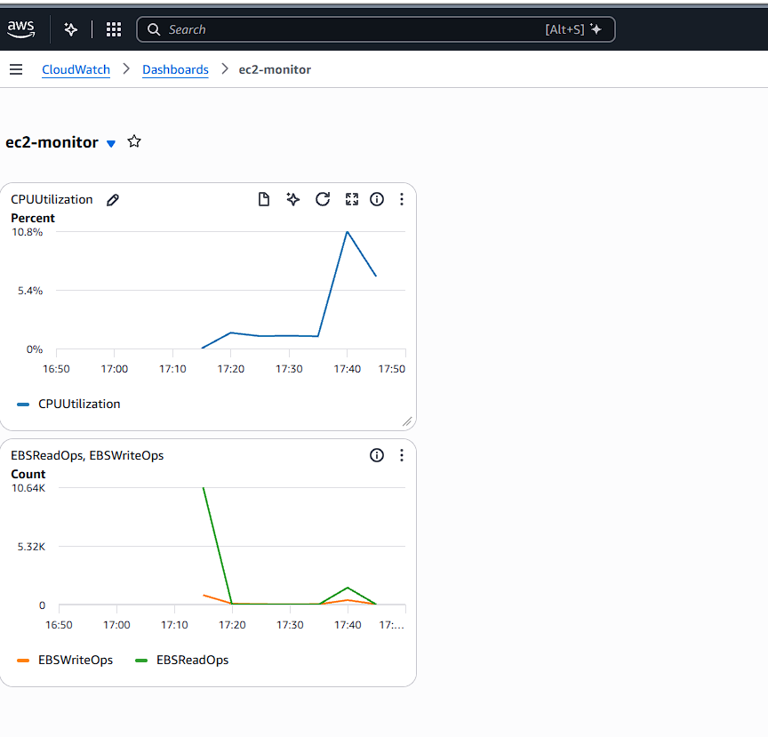
- Create one alarm to send an alert to email if the CPU utilization is more than 70 percent.
I configured the alarm for CPU Util >70 %.
Previously, CPU util was normal. Just put some extra load using aws CLI command.
CPU util increased more than 70%. So, I got a mail through my configuration.
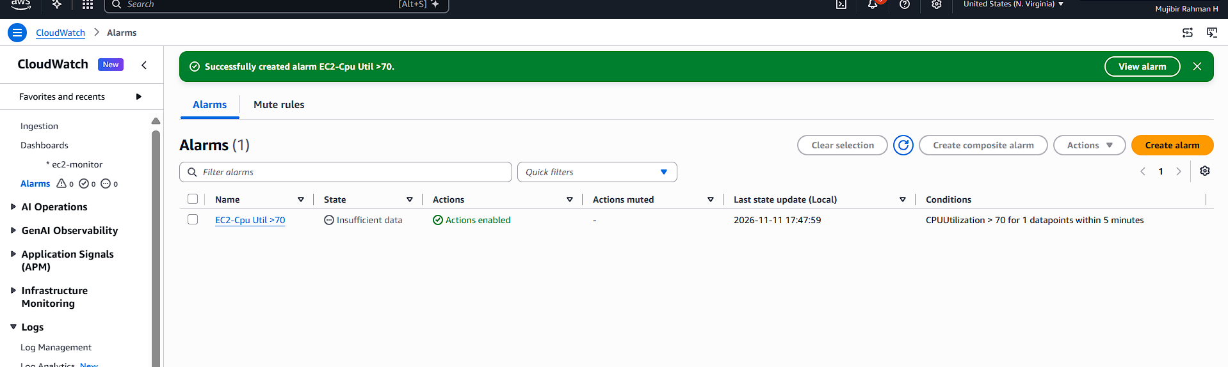
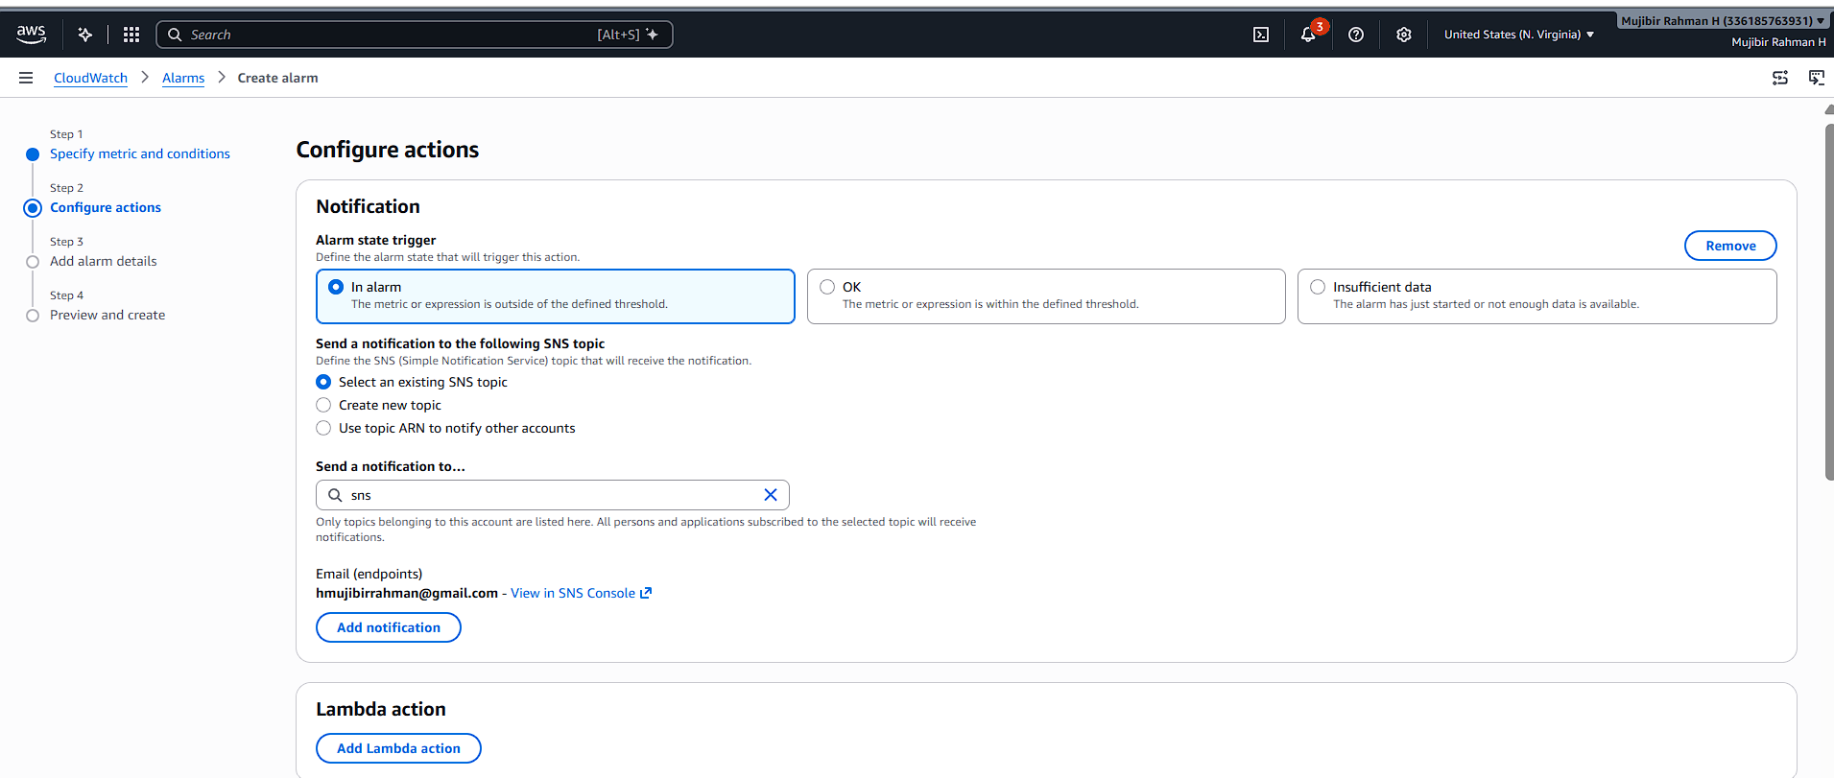
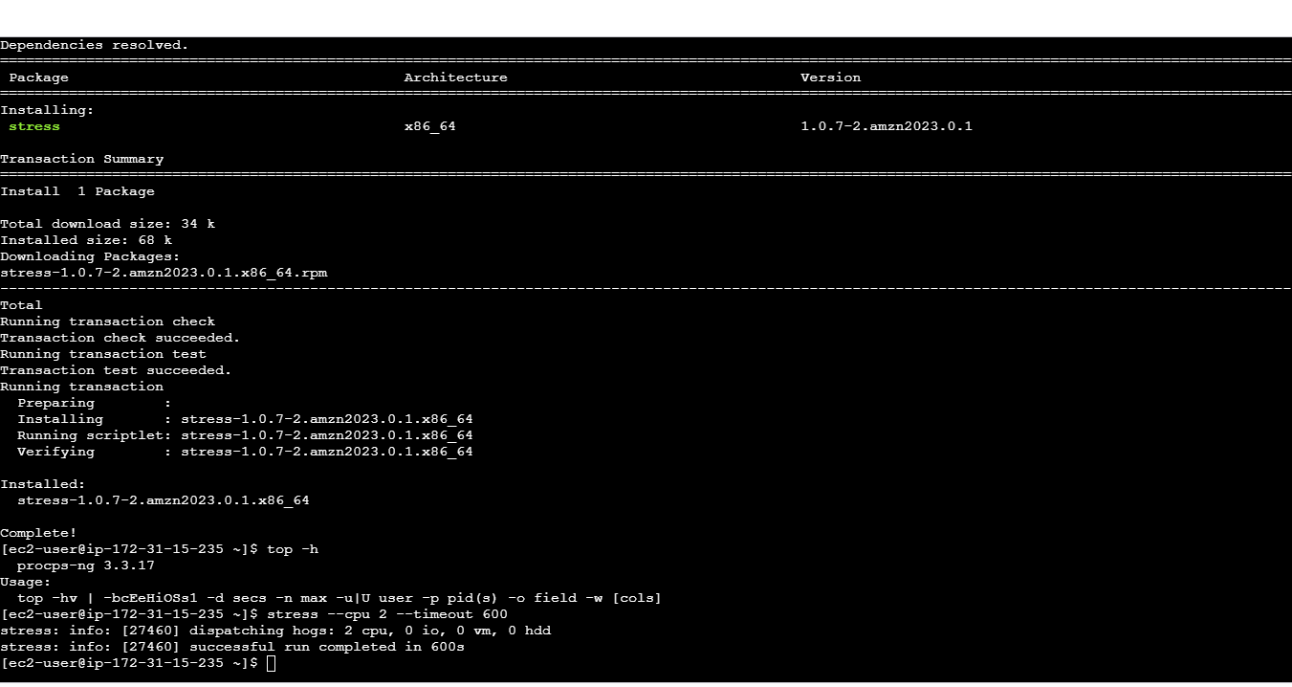
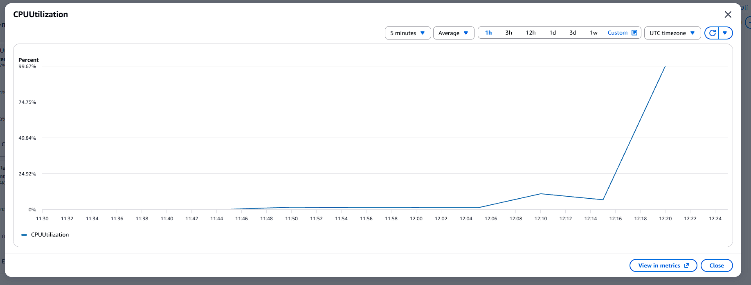
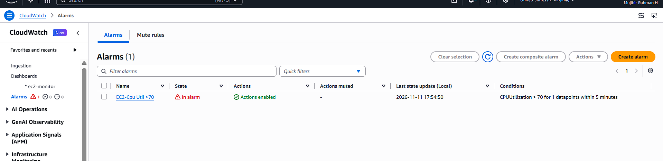
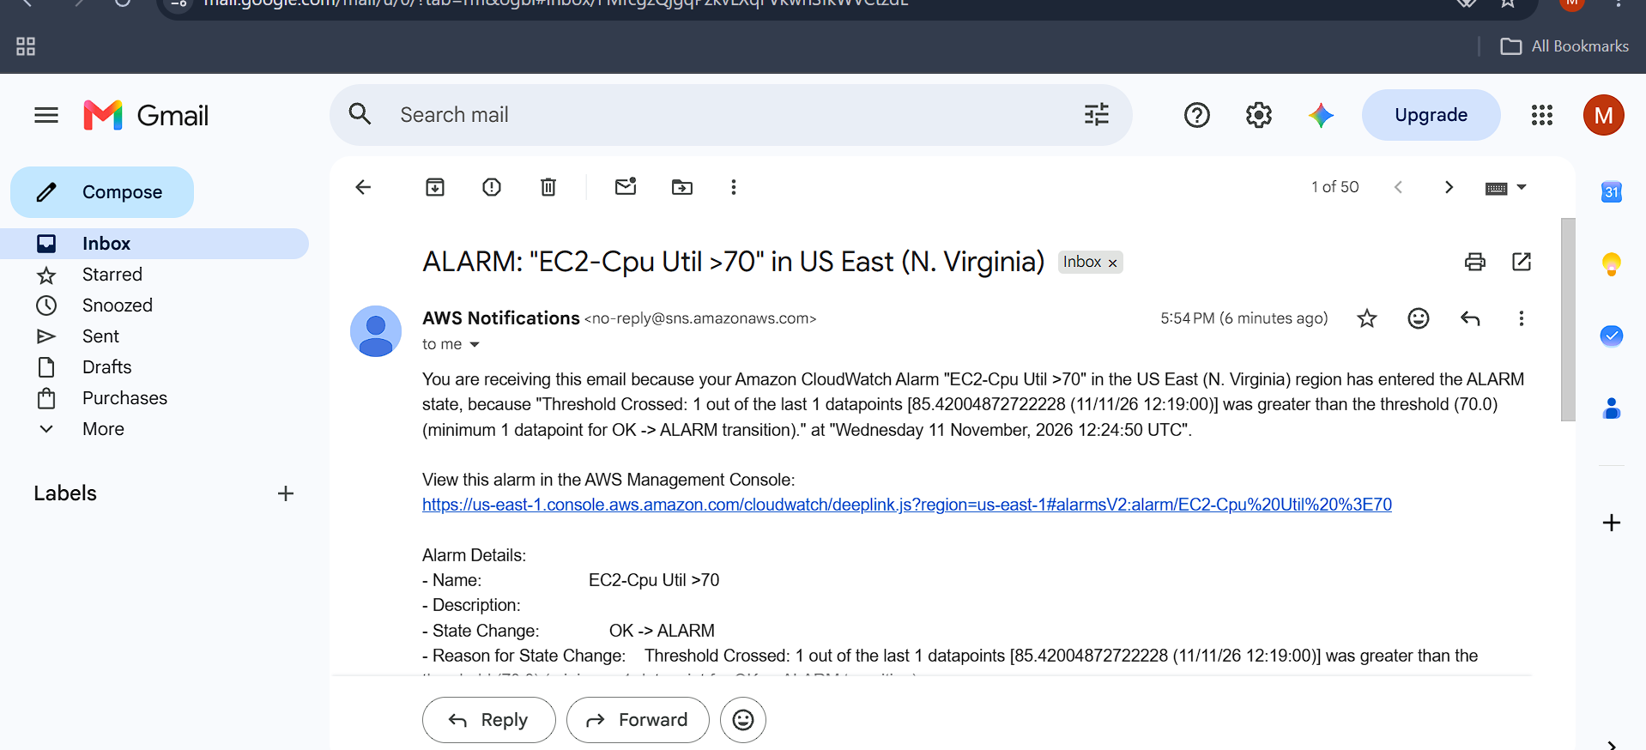
- Create a Dashboard and monitor the Tomcat service whether it is running or not and send the alert.
I created one EC2 instance and installed tomcat10.
Meanwhile, I created the Cloudwatch dashboard and metrics for Tomcat service to monitor.
After this setup, I written the script for monitor the tomcat service and schedule that in crontab (every 1min).
If Instance is running, Dashboard we are able to see 1.
I stop the tomcat service and waited for the mail alert. Mail received for tomcat service is not running.
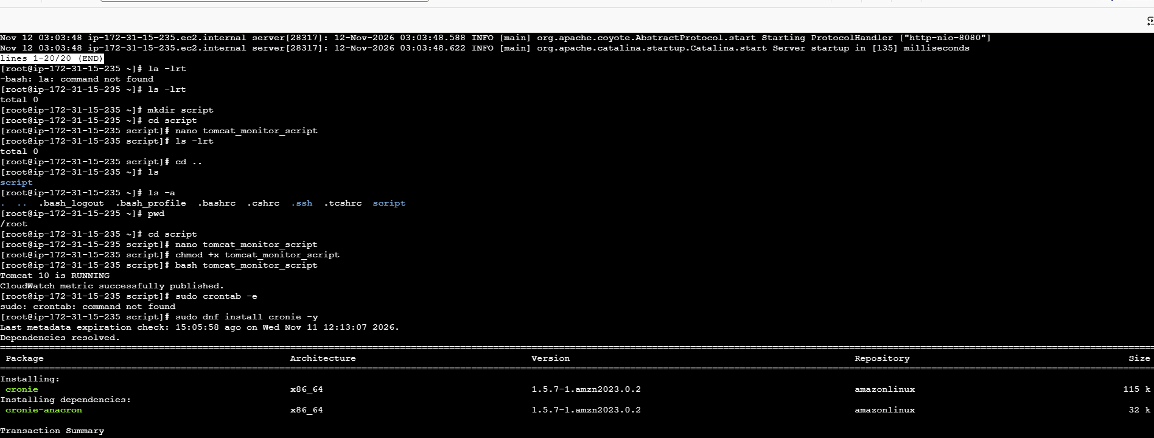
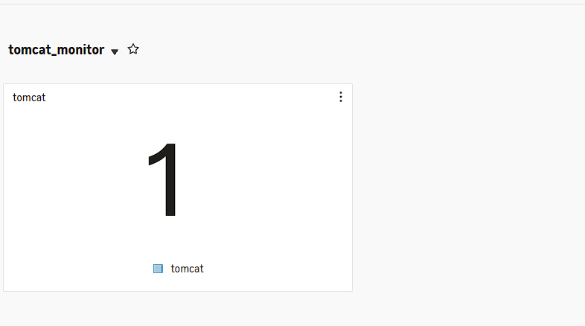
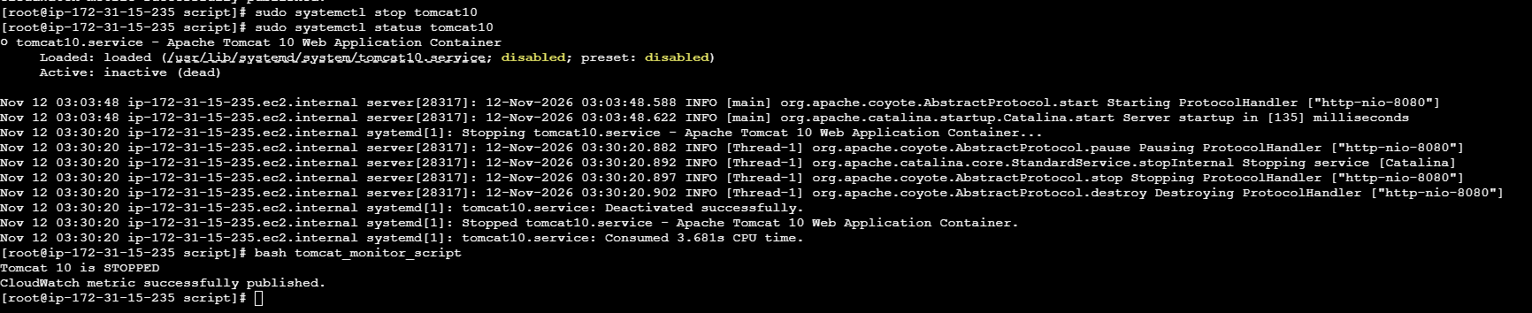
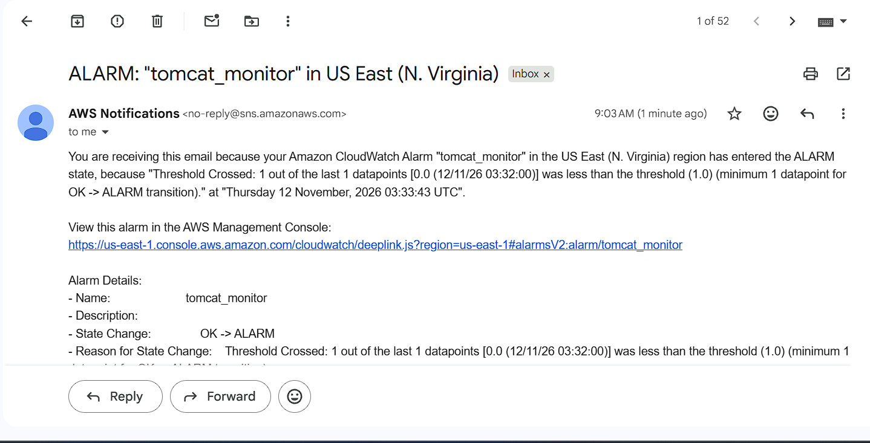
- Create a Dashboard and monitor the Nginx service to send the alert if Nginx is not running.
I created one EC2 instance and installed nginx.
Meanwhile, I created the Cloudwatch dashboard and metrics for nginx service to monitor.
After this setup, I written the script for monitor the nginx service and schedule that in crontab (every 1min).
If Instance is running, Dashboard we are able to see 1.
I stop the nginx service and waited for the mail alert. Mail received for nginx service is not running.


